In this assignment, I am submitting the code that I wrote for applying the force graph.

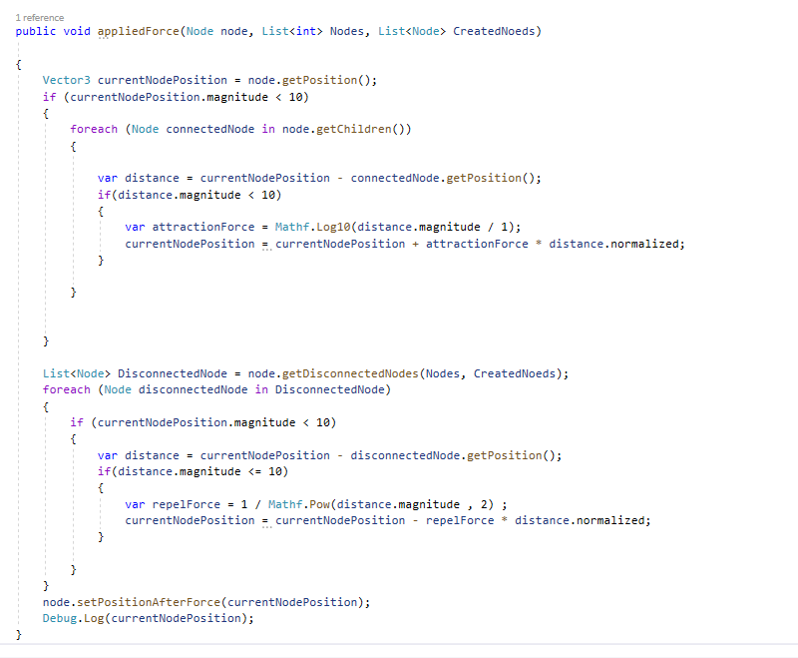

There are some notes that should be considered:

First, I have already created a class called Node, which has a couple of features like vector3 position, and a list of nodes that are connected to that node, which are called children. I also have a list of nodes in general level that keeps track of generated nodes. I also have a list of integers that keeps track of the index of generated nodes that corresponds to their index from the dataset. I also have a method that generates the disconnected nodes from each node given the list of created nodes and the list of node indices that are available in the global level.

In the above method, what I am doing is to iterate the function in run-time on each generated node and try to update its position by calling setPosition function after finding the generated forces. I am using two forces, attraction with logarithmic level and repelling with power function) given the relative position of each node from each children and disconnected nodes. I am also litming the magnitude to be less than 10 (I do not know why this model is not converging for the given data). Anyway, the method updates the position